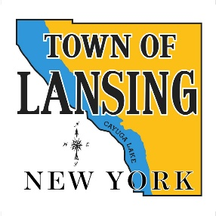 | Conservation Advisory Council
 | December 4, 2024
6:30 In Person
Lansing Town Hall
MINUTES

1. Call Meeting to Order
Present: Ed Dubovi, Robyn Bailey, Lisa Scanlon
Absent: John Fleming, Todd Walters, Brian Boerman,
Non-CAC attendees: Siobhan Hull, CCE; David Ogden, John Dennis

2. Discussion of the DEC negative declaration for Cargill project
The CAC was asked by the Town Board to review the negative environmental impact finding by the DEC of a project proposed by Cargill to flood a portion of an abandoned mined area under the southern part of Cayuga Lake. The CAC invited John Dennis to give a presentation on ongoing efforts to require a full EIS for the salt mine. A review of ongoing concerns surrounding the continued operation of the salt mine was given with some specific issues related to the flooding of the non-active area. The CAC has no members with expertise in the areas needed to respond to the Town Board with a meaningful recommendation in the short period of time allotted. Also, with only 3 CAC members in attendance, a quorum was not present to do business. As an extension to the comment period until Jan 19 was approved by the DEC, the CAC will take up this issue again at the 1-8 meeting.
3. Departmental and Committee Reports
There were no committee reports

