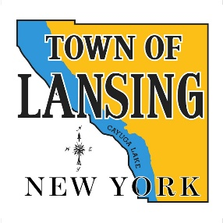 | Conservation Advisory Council
 | January 8, 2025
6:30 In Person
Lansing Community Library
MINUTES

1. Call Meeting to Order
Present: Ed Dubovi, Robyn Bailey, Todd Walters, Brian Boerman, John Fleming, John Hatfield, Travis Kitch
Excused Absence: Lisa Scanlon
Non-CAC attendees: Siobhan Hull, CCE; John Dennis, Ruth Groff, Joe Wetmore, Tom Butler

A quorum of the CAC members was present.

2. Discussion of the DEC negative declaration for Cargill project continued
The CAC was asked by the Town Board to forward a resolution dealing with the DEC’s negative declaration concerning a request by Cargill to approve a modification to their permit involving flooding of an abandoned section of the mine with water that enters the operation. Several drafts of a resolution were discussed. A final draft requesting the DEC to reverse their decision that the flooding of the S3 section of the mine would have a negative environmental impact and for the DEC to hold public meetings to address community concerns was put to a vote. The motion to move the resolution to the Town Board was approved – 7 in favor – 0 opposed.
3. Departmental and Committee Reports
A brief report was given by Ed Dubovi, Town of Lansing rep on the county Environmental Management Council concerning the December meeting. The agenda for the January 9 meeting and the minutes for the December meeting were sent to members of the committee.
4. Next CAC meeting will be 2-5 at 6:30 in the Town Hall. Jon Negley representing the TC Soil and Water Conservation District will give a presentation.

