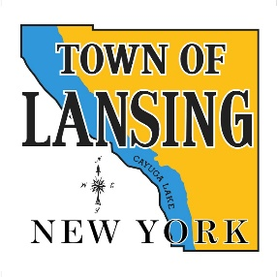 | Conservation Advisory Council
In person meeting
6:30 PM
Town Hall Board Room
 | Wed September 4, 2024
Agenda

1. Call Meeting to Order

2. Update on the Proposed Town Resolution on Status of Norfolk Southern Property

3. Presentation by Jerry Sheng from CCE on the Climate Smart Communities program
a. CAC and Climate Resilience planning
4. Scheduled October 2 meeting.

5. Departmental and Committee Reports

